MySQL database:

1. **REGISTERED_ACCOUNTS:** This table stores the records of the users who has registered on the

Website.

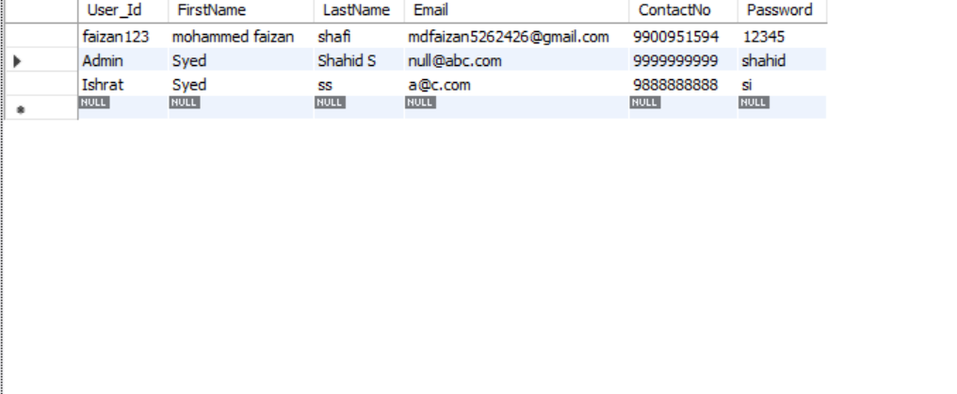

1. **LOGIN :** this table stores the records of current logged in users .

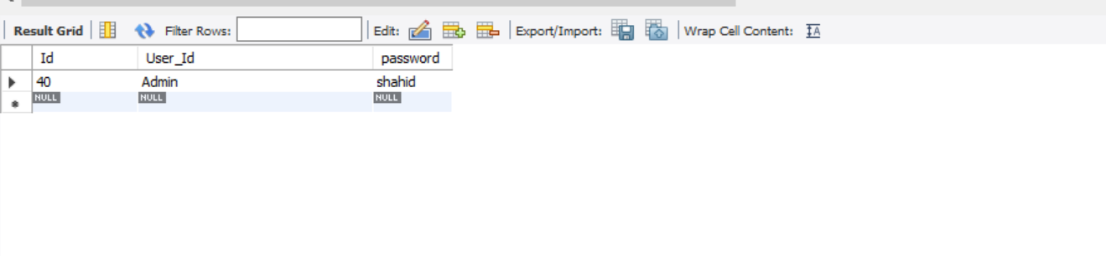

1. **FLIGHT_DETAILS:** this table stores the records of the flights available from source-destination , departure date , flight_id etc…

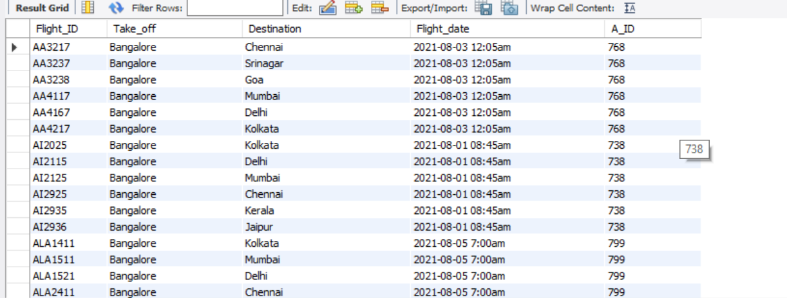

1. **PASSENGER_DETAILS:** this table stores the records of the passenger’s passport details like passport_id , Passenger_name, age, gender, contact number, address and the flight_id in which he is travelling.

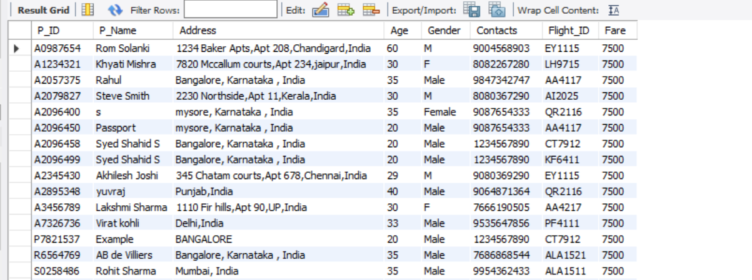

1. **Tickets:** this table stores the records of all the tickets booked by the passengers.

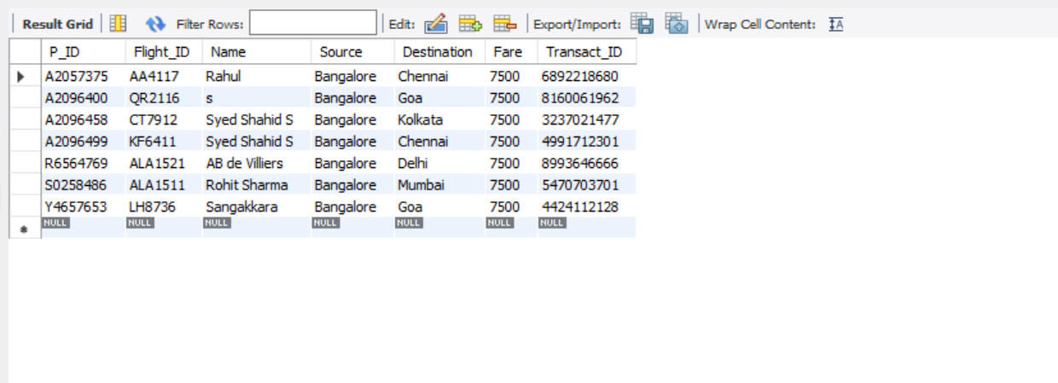

1. **CONTACT_FORM:** this table stores the records of the Queries or Helps asked by the users.

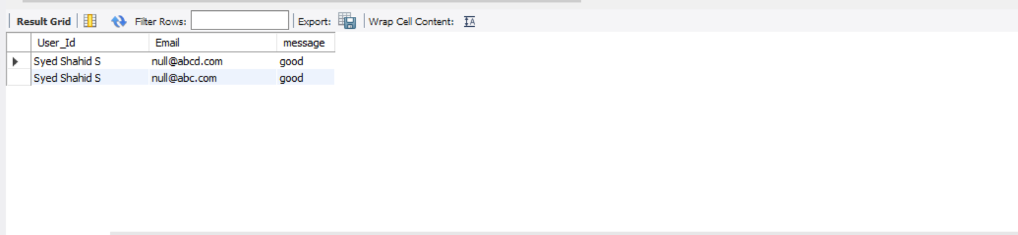

1. **FEEDBACK_FORM:** this table stores the records of the feedbacks given by the users.

